Retail management application using salesforce

# Introduction

* 1. **Overview**

The project topic we are covering is “Retail management application using salesforce”. Retailing encompasses the business activities involved in sellinggoods and services to consumers for their personal, family, or households etc.,

# Purpose

A CRM product owner has requested to create two applications, one is sales app for sales reps to use this application and store customers data, and the second is a service app for service reps/agents to provide support to customers in dealing cases. This can help field sales teams ensure that ordersare fulfilled quickly and accurately and that inventory levels are maintained at optimal levels.

# Problem Definition and Design Thinking

* 1. **Empathy Map**

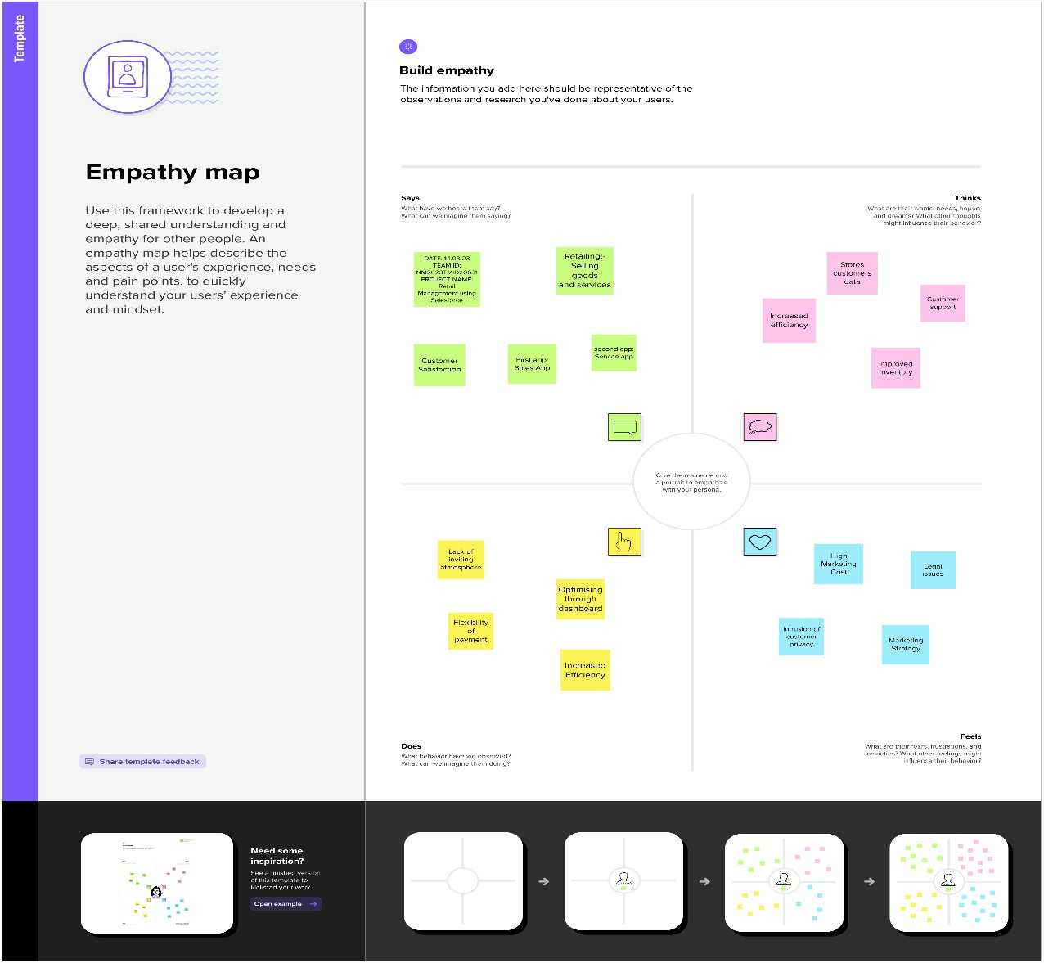

# Ideation and Brainstorming Map

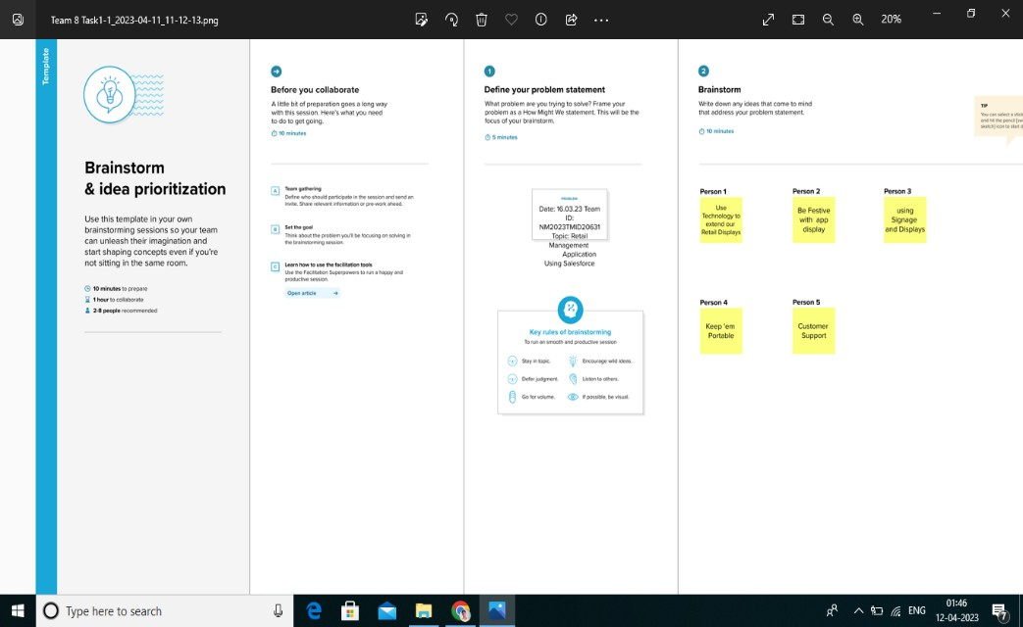

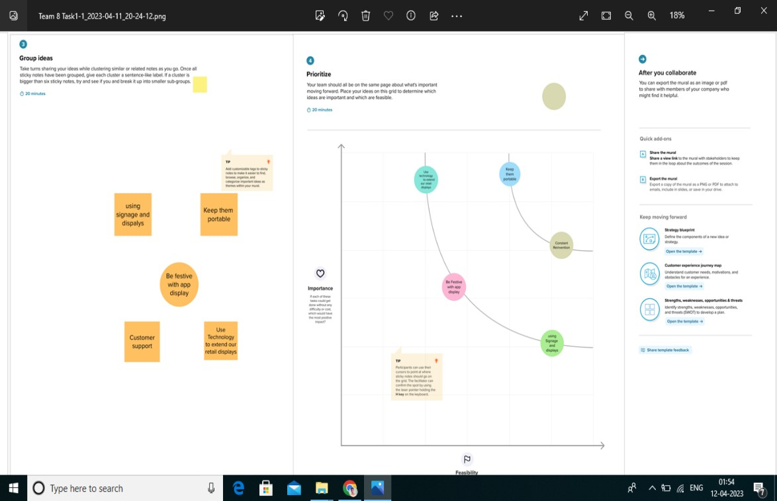

**RESULT:**

|  |  |  |  |  |  |
| --- | --- | --- | --- | --- | --- |
| Application | Fields in the object | | | | |
| Sales app |  | | | | |
|  | Field label | | Data type |  |
| Warehouse | | Check box |
| Accounts | | Check box |
|  | | | | |
| Services app |  | | | | |
|  | | Field label | Data type |  |
| Case | Master Detail Relationship |
| Accounts | Master Detail Relationship |
|  | | | | |

# Activity and Screenshot M1 :

**Activity :-**

* + - Creating developer account
    - Account Activation
    - Salesforce login M2:

Activity 1:-

Creation of object Dispatch/Tracking

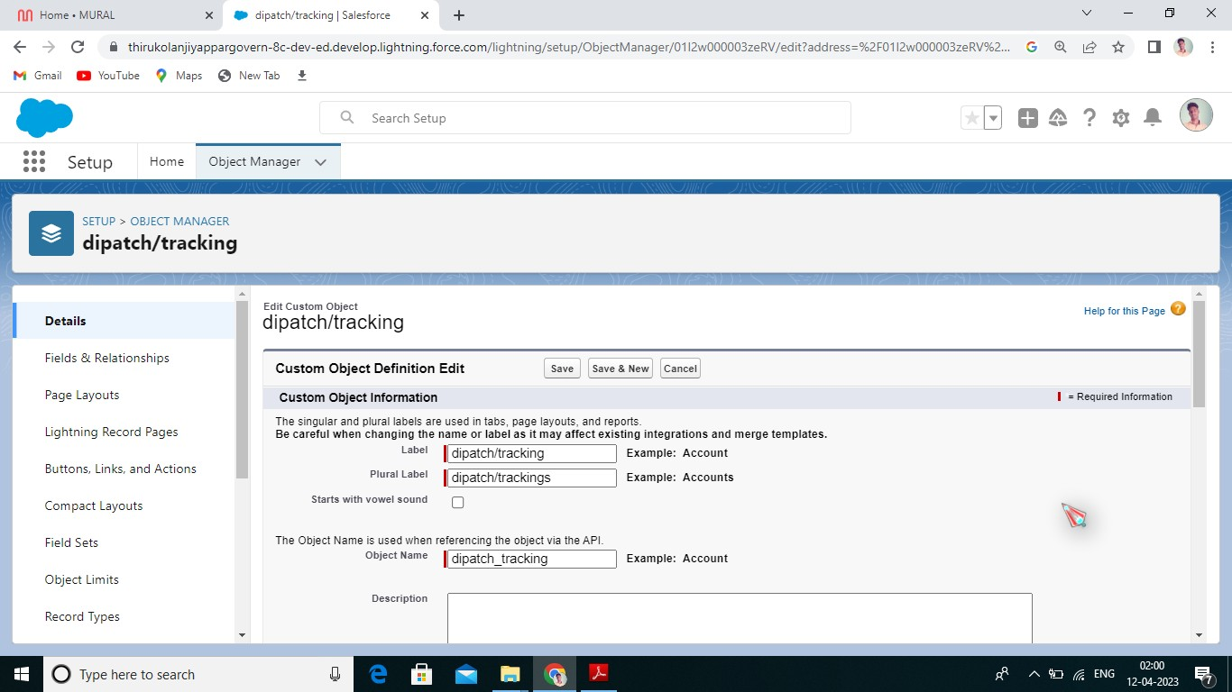

A2: Fields available on Dispatch/Tracking

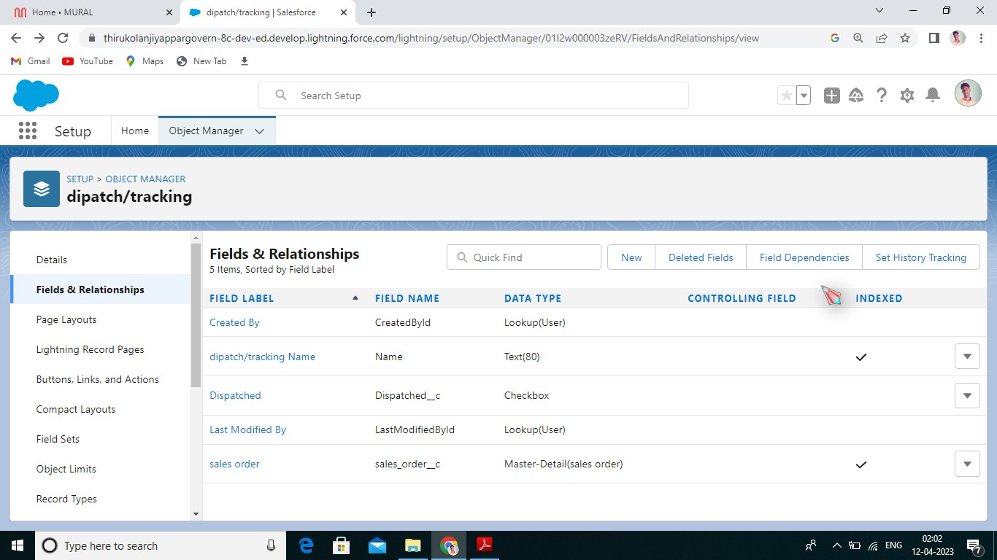

M3 A1: Relationship between objects

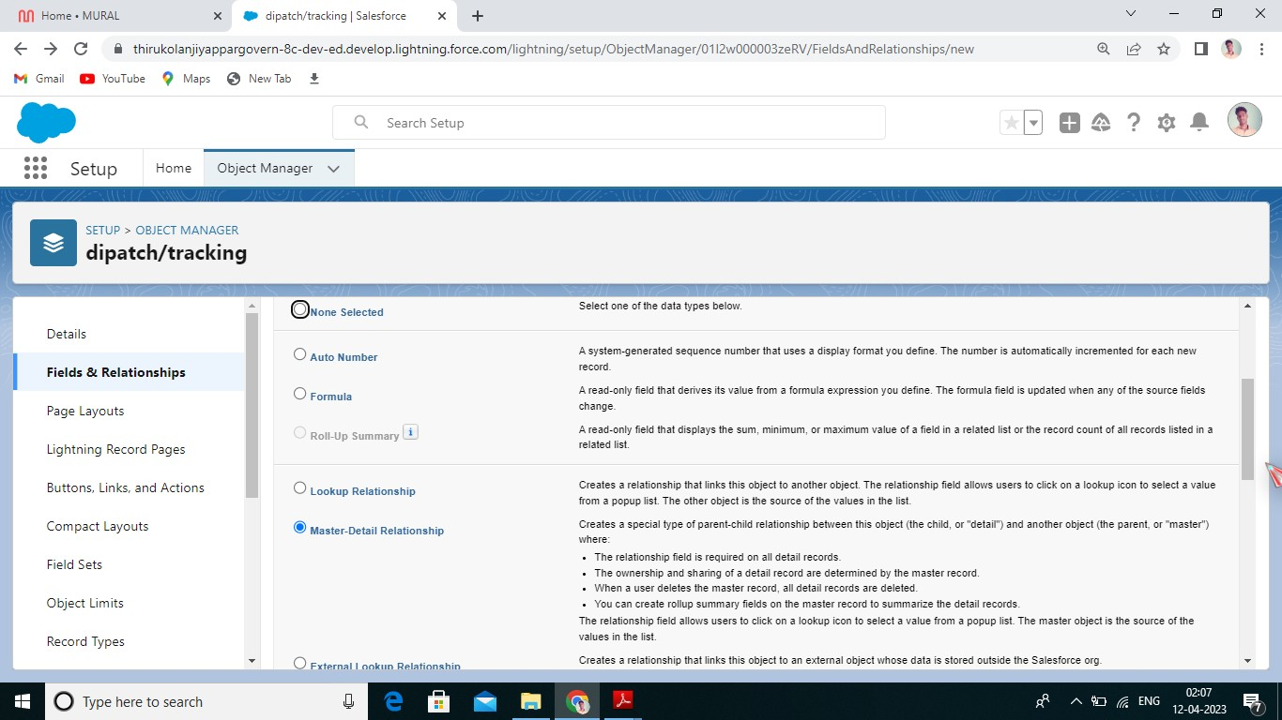

M4 A1: Creation of application

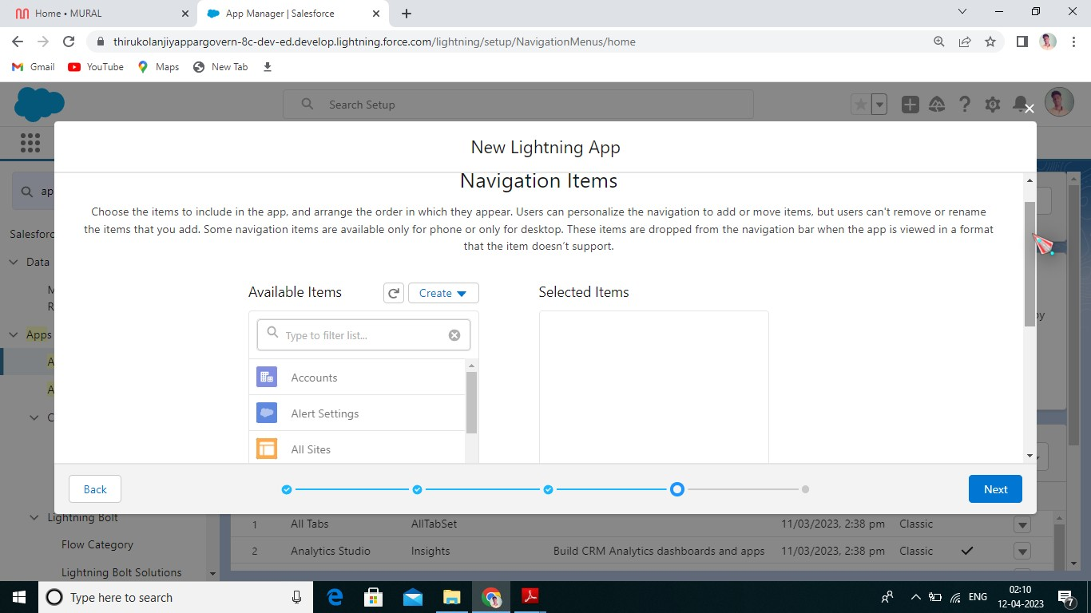

M5 A1: Creation of custom tabs

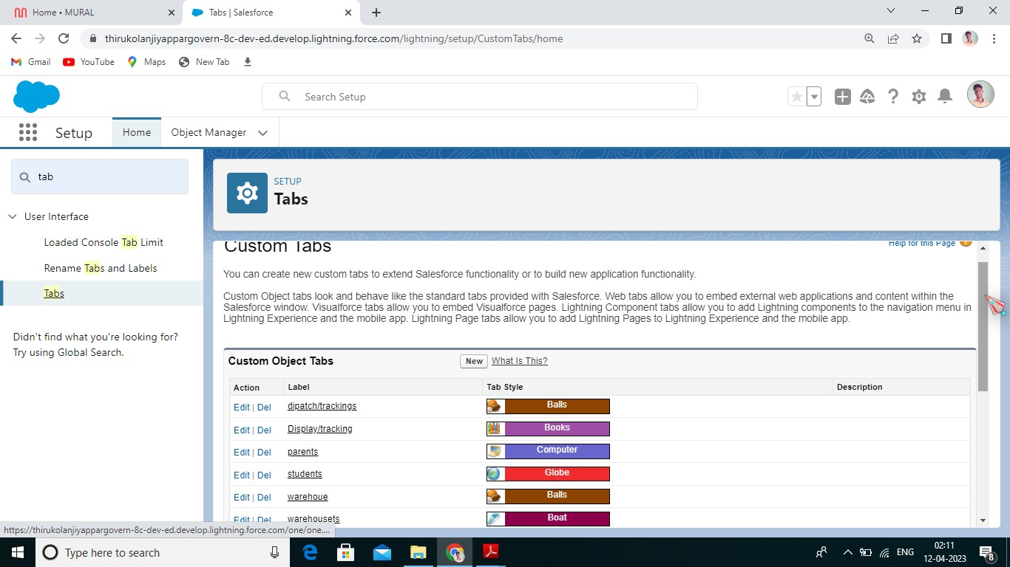

M6 A1 Creation of user

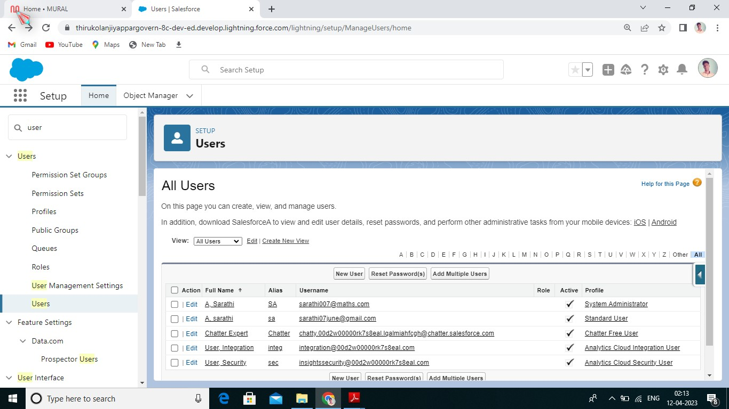

M7 A1: Creation of validation rules

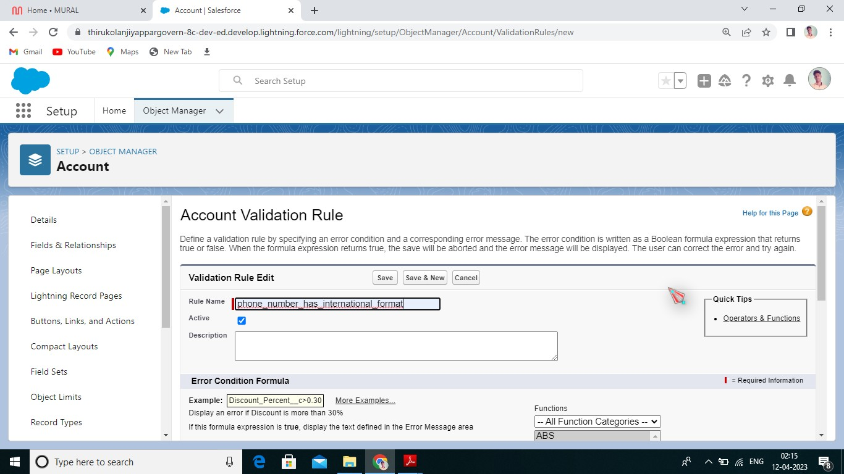

M7 A2: Creation of cross-objects

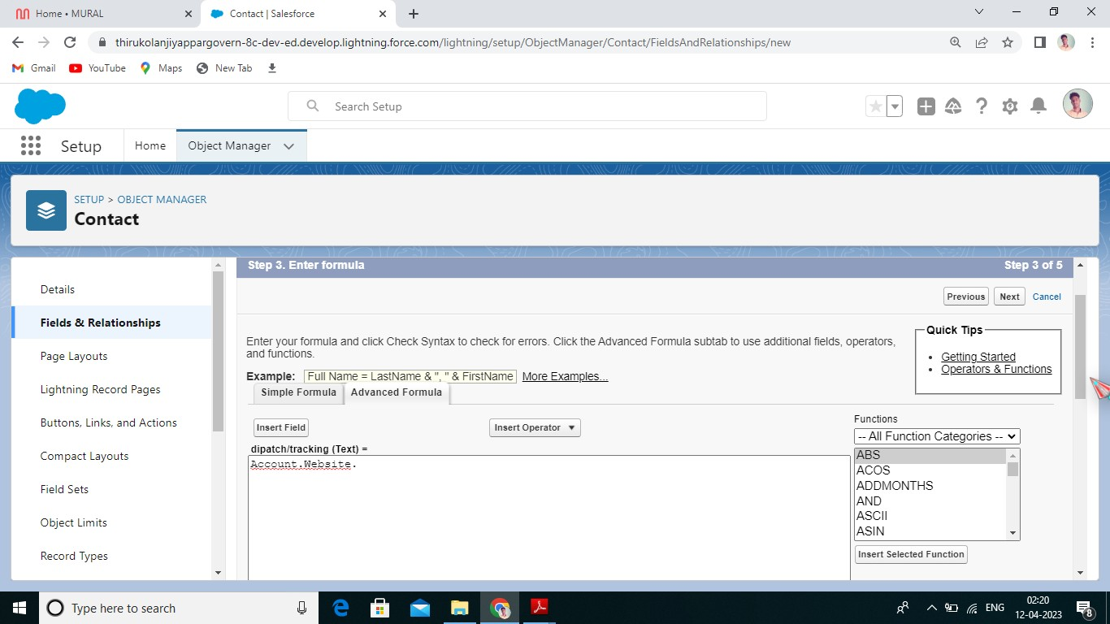

M7 A1: Creation of reports

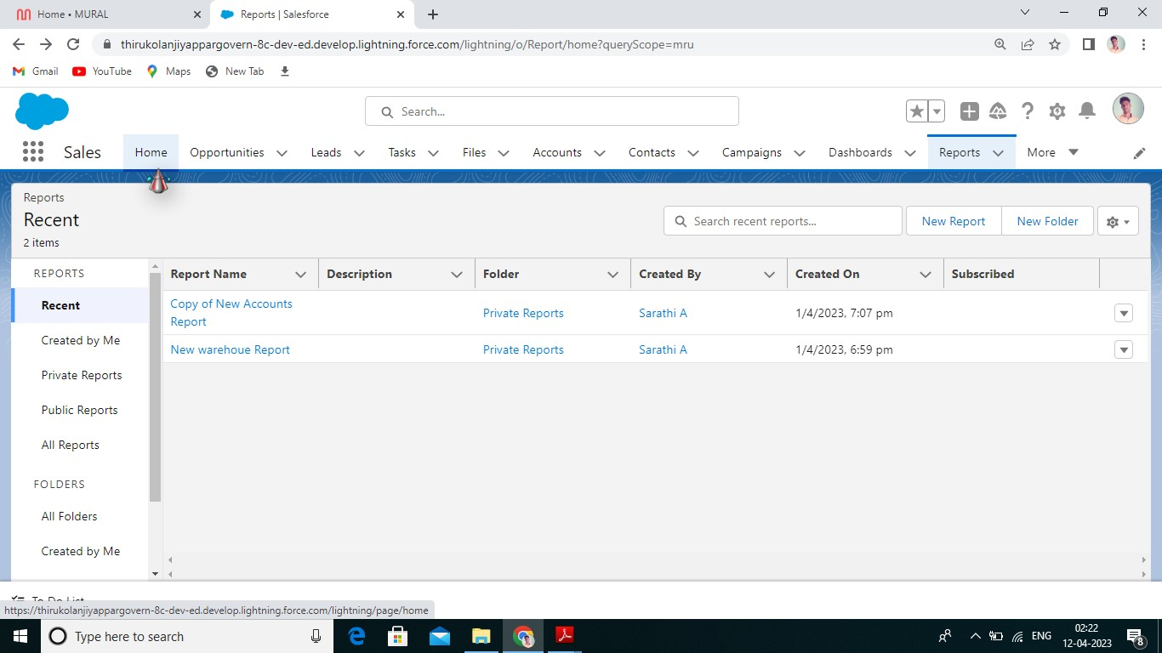

M7 A1: Creation of dashboard

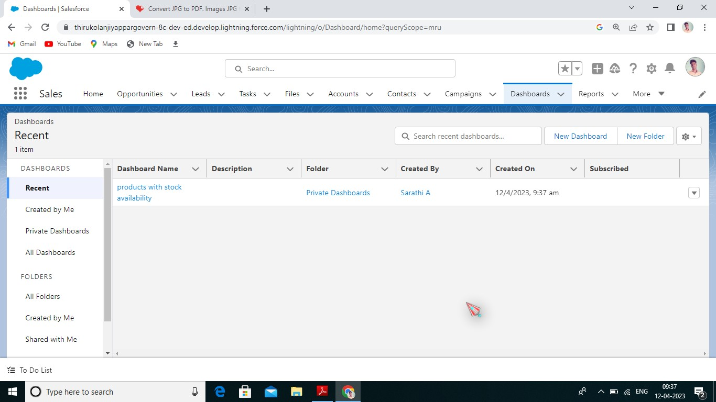

# Trialhead profile public URL

Team Leader : SNEHA.P

https://trailblazer.me/id/ssneha63

Team member : VANITHA.P https://trailblazer.me/id/uvanitha

Team member : NITHYASRI.P http://trailblazer.me/id/srisspp

Team member : RAMYA.M <https://trailblazer.me/id/ramyn16>

Team member : AKILANDESWARI.M

https://trailblazer.me/id/karum38

# Advantages

* + High Marketing Cost
  + Optimising through dashboard
  + Stores customers data
  + Improved inventory

# Disadvantages

* + High Marketing Cost
  + Legal issues
  + Intrusion of customer privacy
  + Lack of inviting atmosphere

# Application

* + The mobile app allows your sales team to address customer needs quickly.
  + It improves customer relationships.
  + A mobile app boosts inventory.
  + It provides instant access to product information.

# Conclusion

Today, most of the traffic online is powered by mobile devices. Getting a mobile app for your business puts you in the right position to leverage this trend.

From the branding perspective to customer service and marketing, there are hardly any departments of your business that won’t benefit from incorporating a mobile app.

# Future Scope

One of the primary reasons why businesses need mobile applications is to improve sales. The technology provides a new medium to interact with prospective consumers, creating value in their daily life and possibly trying to make sales, The channel can be utilized to get other details of consumers which can help in improving marketing strategies.